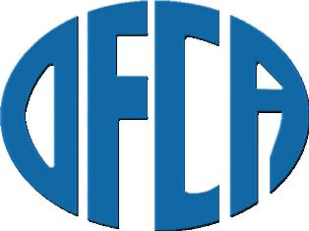

OFCA NOTIFICATION OF TRANSFER

Please be advised that the following student has requested a records transfer:

Student name: ____________________________
Student DOB or ICA Number: _____________________
Old Company: ____________________________
New Company: ___________________________

________________________/_______
Student Signature/Date

Note: By submitting this form, you are representing that you have notified the previous company of this transfer request. This form can be used to notify the previous company as well as the OFCA database administrator.
There is a one-time charge for a student transfer of $7.50. You will need to pay this fee when you login to the OFCA database before you will be able to print an IQCS card for this employee.

Please fax this form to 503-977-6060 or email it to d.sanders@ofca.co

